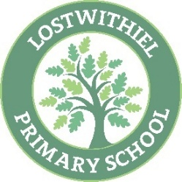
Lostwithiel School - Year 3 Reading Overview

Reading for Pleasure | The Wild Robot  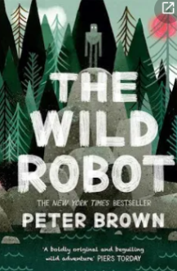 | Alien in the Jam Factory  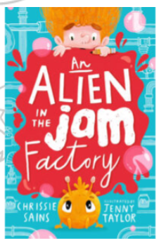 | The Iron Man  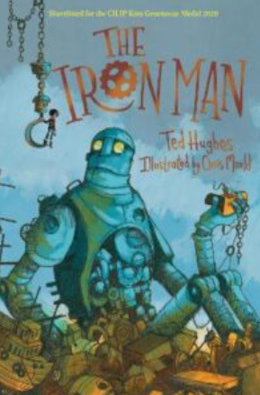 | Charlie Changes into a Chicken  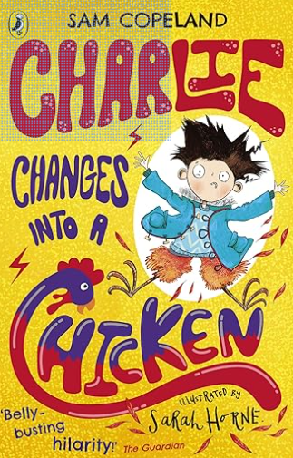 | The Land of Roar  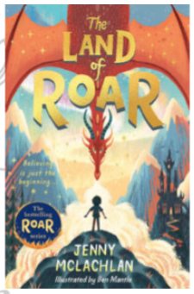 | The Girl who Stole an Elephant  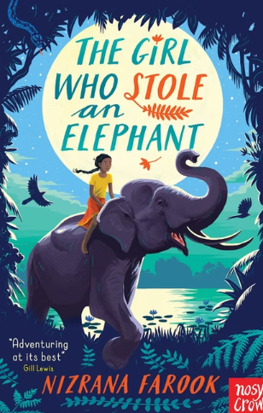
Whole Class Reading Texts | Journey to the River Sea  (5.6) | Science Non-chronological – The Human Skeleton & the Five Senses  Fiction Play script – Christmas in Halloween Town & Marley’s Ghost | History Non-chronological – Hunter Gatherers & The Great Fire of London  Traditional Tales – The Elves & the Shoemaker and Rumpelstiltskin | History – explanation text– How were the dead mummified & Why do we have four seasons?  Fiction – Myths and Legends – King Midas & The Boy Who Cried Wolf | Poetry – On the Day of the Dead & The Last Leaf  History narrative – Florence Nightingale & Jane’s Jungle Journey  Geography Non chronological report– Regions of England & Capital Cities of the UK (R & P) | Skandar and the Unicorn Thief (5.7)
Justification for choice | Research-informed practice based on the Mary Myatt ‘A faster read’ programme and research by the University of Sussex. St Mewan trial – 73% Spring to 81% EXS TA 23/24 | Cross Curricular link – Science – Retrieval from last term.  A range of text types | Cross Curricular link – History Retrieval from Y2.  A range of text types & literary heritage. | Cross Curricular link – History Retrieval from Autumn & retrieval from KS1 Science.  A range of text types & literary heritage. | Poetry inclusion and knowledge and understanding of the world.  Cross Curricular link – History Retrieval from Y2.  Cross Curricular link – expand - regions of the UK builds on River’s and mountain knowledge and KS1 geography learning. | Research-informed practice based on the Mary Myatt ‘A faster read’ programme and research by the University of Sussex. St Mewan trial – 73% Spring to 81% EXS TA 23/24
Reading Skills | Summary  Retrieval  RFP  Fluency  Vocab` | Retrieve  Infer  Summarise  Vocab  Fluency | Vocab  Infer  Retrieve  Sequence  Fluency | Vocab  Infer  Summarise  Retrieve  Fluency | Retrieve  Infer  Vocab  Summarise  Fluency | Summary  Retrieval  RFP  Fluency  Vocab`
Reading questions | Who?  What?  Where?  Why?  When?  How?  Inference questions.  Evidence  Explain | Find & Copy  How was/did  True/False  Find and copy  What?  Why? | Is closest in meaning to  What?  Why?  How can you tell?  Circle  Number the facts | Find & copy  What?  Why?  Why did/was  Given an example  This means that… | What/When/Where  This means that  True or False  In this sentence  What else?  Find an example  Draw a line  Give one way  Tick one box in each row | Who?  What?  Where?  Why?  When?  How?  Inference questions.  Evidence  Explain

