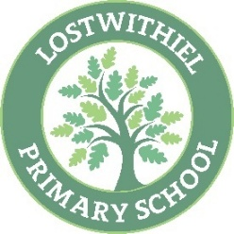
Lostwithiel School - Year 2 Reading Overviews

Year 2 Class Favourites | 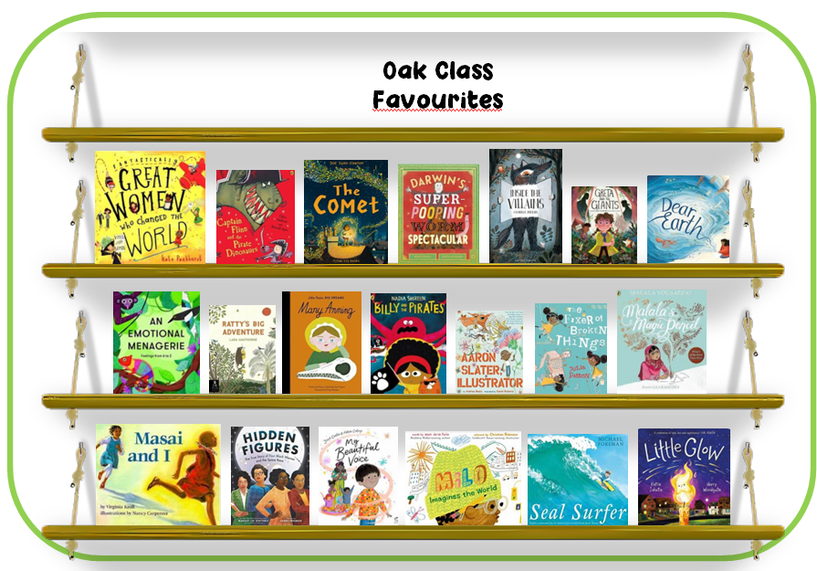
Year 2 RfP | Marv and the Mega Robot  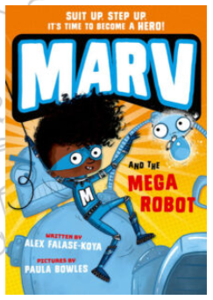 | Dave the Pigeon  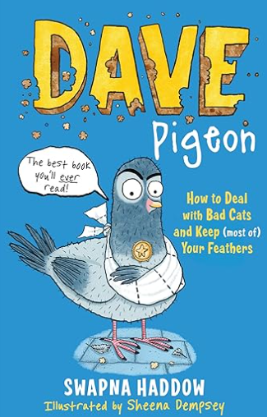 | Flat Stanley – The Great Egyptian Grave Robbery  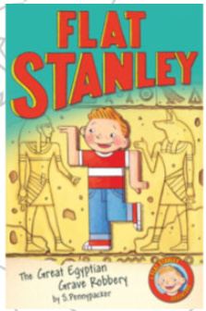 | Einstein the Penguin  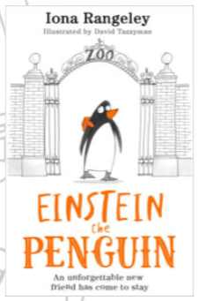 | Leonora Bolt  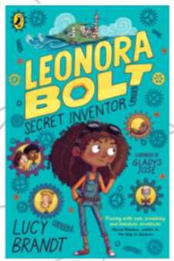 | The Boy Who Grew Dragons  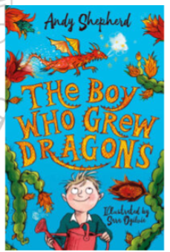
Whole Class Reading  Texts | RWI | RWI | Animal Groups – Insects  A magical Christmas – The Missing Mince Pies  Changes in mobile phones/Changes in toys | Village, town or a city? - Capital cities and countries of the UK  The enormous Carrot – Macaroon Man  Castles through the ages – Materials | I’ve seen a moose bake banana bread - My dog is not the smartest dog  Monarchs of England and Great Britain/Queen Elizabeth I  The Legend of Nian - The Bird King | Charlotte’s Web (4.4)  The Accidental Pirates: Voyage to Magical North (5.1)
Justification | Children will be completing RWI programme as per scheme expectations and guidance. This is informed by thorough assessment of child’s ability to decode words, read words at-a-glance and reading speed. The scheme and guidance is followed with fidelity. |  | Cross Curricular link – Science – Retrieval from Y1  A range of text types & literary heritage.  Cross Curricular link – History – Retrieval from EYFS | Cross Curricular link – Geography – Retrieval from Y1  A range of text types & literary heritage.  Cross Curricular link – History/Science – Retrieval from Y1 | A range of text types – poetry  Cross Curricular link – History – Retrieval from Y1  Stories from other cultures  sequencing, vocabulary & meaning and inference skills | Research-informed practice based on the Mary Myatt ‘A faster read’ programme and research by the University of Sussex. St Mewan trial – 73% Spring to 81% EXS TA 23/24
Reading  Skills | Inference, checking for meaning and understanding, inference, retrieval, prediction, correcting inaccurate reading, vocabulary, drawing on background information and recognising simple recurring literary language. |  | Vocabulary  Retrieval  Sequencing  Inference | Vocabulary  Retrieval  Sequencing  Inference | Retrieval  Inference  Sequencing  Vocabulary & Meaning | Summary  Retrieval  RFP  Fluency  Vocab`

