Lostwithiel School - Reading Overview for Year 5/6
Year 6 Reading for Pleasure | The Girl of Ink and Stars  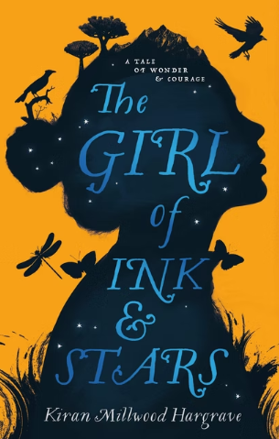 | Darwin’s Dragons  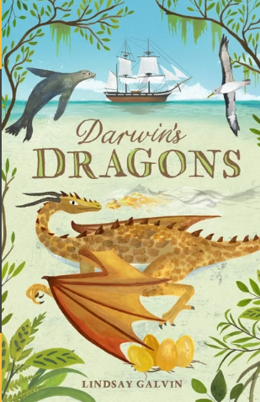 | The Nowhere Emporium  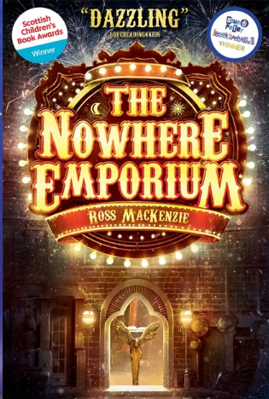 | Wolf Wilder 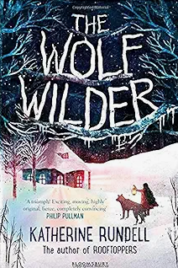 | Trash  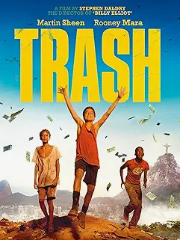 | The Final Year  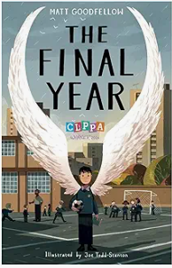
Whole Class Reading Texts | The Peculiar Tale of Tentacle Boy (7.0) | Narrative - Cyberbullying – Medusa  Non-Chronological Reports Imports and Exports of the UK - Biomes of the world  Narrative Poetry - Diwali Dreams - The Bonfire at Night | Non-Chronological report - Gothic Fiction Characters/Maya  A Christmas carol: Marley’s ghost/Bob Cratchit’s house  Desert Creatures/Desert Biomes | Biography - Katherine Ferrers - Julius Caesar  Playscripts - Hamlet/Macbeth  Non-Chronological Report/Letter – Migration to the UK/Windrush Passenger | Discussion - A day in the life of a Cardiologist/A day in the life of a Pharaoh  Newspaper Reports - New species discovered in the Galapagos/Moon landing | Just Reading x2 Just Reading  Which Way Round the Galaxy (7.0)  The Secret of the Black Moon Moth (7.4)  Through the Looking Glass (7.6)  The Fowl Twins (7.5)  Jason and the Argonauts (7.0)  The Adventures of Tom Sawyer (8.0)
Justification | Research-informed practice based on the Mary Myatt ‘A faster read’ programme and research by the University of Sussex.  St Mewan trial  - 73% Spring to 81% EXS Summer TA 23/24.  - 73% EXS or above Rising Stars Autumn to 91% EXS or above Rising stars Summer.  - 25% made better than expected progress. 59% made expected progress. Insight  - 5 months reading progress in 3 months compared to 4 months in other year groups. | Cross Curricular link – History – retrieval from Y4  Cross Curricular link – PSHE  Cross Curricular link – Geography – Retrieval from Y4  A range of text types & Literary Heritage  Cross curricular link – RE – Retrieval from Y4 | A range of text types & literary heritage.  A range of text types & literary heritage.  Cross curricular link – Geography – Retrieval from Y4 | Cross curricular link – The Roman Empire Autumn 2  A range of text types & literary heritage.  Culturally diverse text | Cross Curricular link – Science – Pre-teach Animals inc Humans  Cross Curricular link – History – Retrieval from Y4  Cross-Curricular Link – Retrieval Y5 Science/ Pre teach and retrieval for Evolution | Research-informed practice based on the Mary Myatt ‘A faster read’ programme and research by the University of Sussex.  St Mewan trial  - 73% Spring to 81% EXS Summer TA 23/24.  - 73% EXS or above Rising Stars Autumn to 91% EXS or above Rising stars Summer.  - 25% made better than expected progress. 59% made expected progress. Insight  - 5 months reading progress in 3 months compared to 4 months in other year groups.
Skills | Fluency  Vocab`  Summar  Retrieval | Vocabulary  Retrieval  Inference | Vocabulary  Retrieval | Retrieval  Summarising  Inference  Vocabulary | Vocabulary  Retrieval  Summarising | Fluency  Vocab`  Summar  Retrieval

