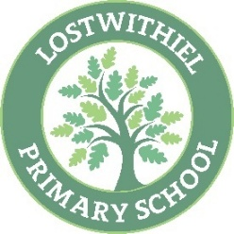
Lostwithiel School - Year 4/5 Reading Overview
Year 4/5 RfP | The Boy at the Back of the Class  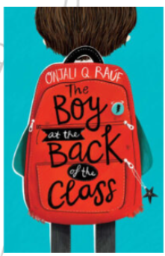 | The Last Bear  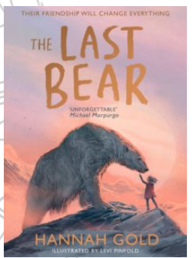 |  | Who Let the Gods Out?  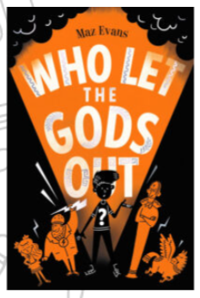 |  | Brightstorm  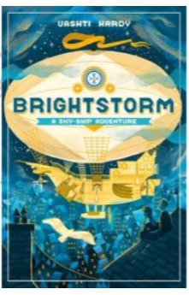 | Holes  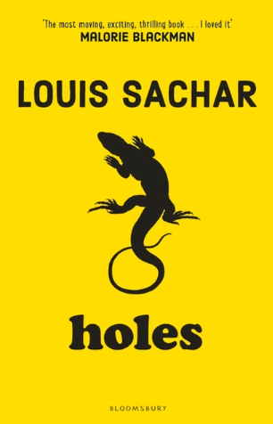 | Wonder  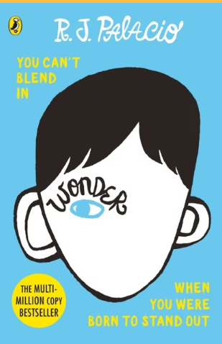
Whole Class Reading  Texts | Greenwild: the world behind the door (6.2) |  | Non-chronological report - Bronze Age Life - Stone Age Life  Persuasive Advert - Ancient Egypt - Visit Incredible Italy |  | Non-chronological report - Iron Age Celts - Egyptian Pharaohs  Narrative – Myth – Apollo & Cassandra – Thesus and the Minotaur | Narrative – Persian Cinderella - The Tomb of Wonder  Non-chronological report – Plymouth - The River Nile and The River Tamar | Explanation Text - How does the ear work?- How do teeth work?  Poem - Storyteller of the Sky – Storm at Sea  Non-chronological report – The River Nile - Black Britons  Nonchronological report – Remarkable Roman Army- Black Britons  Narrative – Religious tale - Lord Krishna – The perfect banquet | The Wolves of Willoughby Chase (6.5)
Justification for choice | Research-informed practice based on the Mary Myatt ‘A faster read’ programme and research by the University of Sussex.  St Mewan trial  - 73% Spring to 81% EXS Summer TA 23/24.  - 73% EXS or above Rising Stars Autumn to 91% EXS or above Rising stars Summer.  - 25% made better than expected progress. 59% made expected progress. Insight  - 5 months reading progress in 3 months compared to 4 months in other year groups. |  | Cross Curricular link – History – Retrieval from Year 3  A range of text types – persuasive  Cross Curricular link – History – Retrieval from Year 3  Knowledge and understanding of the Wider world. |  | Cross Curricular link – History – Retrieval from Year 3  Cross Curricular link – History – Retrieval from Year 3  A range of text types & literary heritage – Myths. Cross-Curricular links to Ancient Greece History. | A range of text types & literary heritage – Traditional Tales.  Cross Curricular link – Geography – Rivers. Retrieval from Year 3.  Cross Curricular link – History Retrieval from Year 3. | Cross Curricular link – Science – retrieval from Y4 Autumn.  Cross Curricular link – Science – retrieval from Y4 Spring.  Poetry inclusion and knowledge and understanding of the world.  Diversity & History link to Romans in Britain – pre-teaching.  RE link – Hinduism | Research-informed practice based on the Mary Myatt ‘A faster read’ programme and research by the University of Sussex.  St Mewan trial  - 73% Spring to 81% EXS Summer TA 23/24.  - 73% EXS or above Rising Stars Autumn to 91% EXS or above Rising stars Summer.  - 25% made better than expected progress. 59% made expected progress. Insight  - 5 months reading progress in 3 months compared to 4 months in other year groups.
Reading Skills | Retrieval  RFP  Fluency  Summary |  | Vocab  Inference  Summary  Evidence  Retrieval |  | Retrieval  Evidence  Identify and Explain  Vocab | Retrieval  Inference  Evidence  Explanation  Vocab | Retrieval  Vocab  Summarise  Inference | Retrieval  RFP  Fluency  Summary

